**Chapter 2 – Behaviour**

*Well controlled behaviour essential to understand brain activity in a reproducible context*

Our understanding of learning and memory depends upon the type of learning that is studied (Schreurs, 1989). Two important categories of learning and memory experiments are,

1. Nonassociative (Habituation and Sensitization), and
2. Associative learning (Classical and Operant Conditioning).

Nonassociative learning paradigms provide information about how an organism responds to repeated presentations of a single stimulus (Brown, 1998). However, it was of interest to us to study how animals responded to a number of events and stimuli being associated, and how the activity of the brain relates to this. Hence, we chose to design our experiments to incorporate Associative Learning, which is a relatively permanent change in behaviour that results from the temporal conjunction of two or more events or stimuli.

Empirically, reproducible behaviour depends on strong associations between the events or stimuli being paired, and may often require many repeated pairings or trials. Additionally, having the animal engage in the behavioural task and pay attention to the stimuli being presented, is crucial to look for important correlations between the experiment conditions (external) and brain activity (internal).

Anaesthetized animals have been previously used to study brain activity, leading to important results in a variety of fields, such as visual representation of moving bars in the visual cortex (Hubel and Weisel paper), habituation in the Hippocampus (Sachin’s paper), etc.. However, what was clear is that similar experiments repeated in awake animals did not result in the same observations. Indeed, animals needed to navigate a known environment before the discovery of Place Cells (O’Keefe and Dostrovsky, 1971), Grid cells (Moser papers), etc. could be made.

The reliability of the overt behavioural responses of the experiment animals then sets the conditions and parameter list to study physiology within the confines of reproducible behavioural contexts, and was considered an important mandate for the standardisation of any of the behavioural tasks described in this chapter.

OPERANT CONDITIONING

*Background of Operant (Instrumental) Conditioning*

Operant Conditioning is both the procedure and a type of associative learning process through which the strength of a voluntarily performed behaviour is modified by reinforcement or punishment. For example, if the animal responds to a presented stimulus by performing a lick onto a water spout, then a water reward would strengthen the behaviour while a Lithium Chloride solution would weaken it.

We now describe our experiments and results with regard to Operant Conditioning.

*Required features for the Operant Conditioning task*

For Project I, the goal was to study how the association of a neutral stimulus with a water reward modified the neurophysiological activity of the Hippocampal CA1. For this, we required the following.

1. An assortment of different stimuli and modalities (light, tone, etc.) to be presented to the animal.
2. The animal must withhold any motor movement during the presentation of the stimuli, to study pure stimulus responses.
3. The animal must perform a lick for a water reward after the end of the stimulus presentation.
4. The animal must be able to make the association between stimuli and water reward within 7 days of training (at the time we did not have the ability to record for multiple days).

The behavioural state of the animal, in terms of anxiety, motivation, attention, etc., may be variable when a naïve animal is presented with different stimuli. This may cause a large variability in the activity of cells, since the animal may not be paying attention to it. Also, if the animal were rewarded for performing the task, it would be motivated to pay attention to the stimuli provided. Finally, such a task would involve the animal associating the stimuli that it is trained to with a behavioural task and this would provide an apt context to study association related changes in stimulus responses.

[Lead-in: in order to achieve these features, these were the tasks we tested]

In this section, I will discuss some important protocols that we tried and tested and a list of the various kinds of behavioural tasks we employed for head-fixed mice.

For Project I, we tried several variations of a Stimulus Detection Task, Delayed Non-Match to Sample (DNMS), as well as a Go/No-Go Task. Each of these tasks requires animals to perform licks to the Conditioned Stimuli and for them to be rewarded (2-3 µL water) or punished based on the task demands and protocol design.

*Water delivery and calibration*

The lick port was made from a trimmed and smoothened 16 gauge syringe, connected to a water reservoir with small diameter tubing. A solenoid valve clamped onto this tubing, gated by a 12V DC signal. When this gate was opened, the volume of water could be regulated by the duration of the 12V DC signal. We calibrated the duration of gate opening to achieve ~2 µL per pulse or spurt (Jaramillo and Zador, 2014). The weight of 100 spurts was measured and then divided by 100 to get the weight of 1 spurt. 65 ms was found to be roughly providing 2.5 µL (this value is going to be used for behaviour). In the figure below, the measured volumes/weights are plotted as blue filled diamonds, error bars are presented as Standard Error and the Linear Trendline is shown in black.

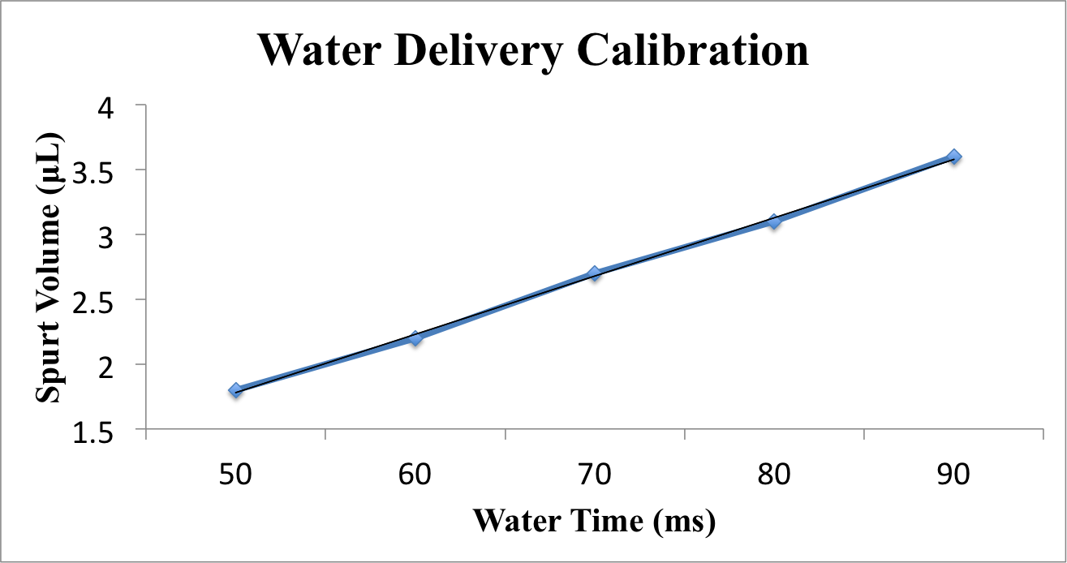

*Optoislator circuit for solenoid control*

To be able to programmatically control the 12V DC line to the solenoid valve, we used the following circuit, which accepted a 5V digital input from the DAQ (NI USB-6001) interfacing the lab computer to the behaviour rig.

Parts list

1. 470 ohm resistor

2. 15 kohm resistor

3. MCT2e

4. ULN2003

5. Bases (adaptors for MCT2e and ULN2003)

6. +5V and +12V DC inputs from a Power Supply)

7. Source of +5V DC input (DAQ, etc.)

8. Connecting wires

9. Load Resistance (Solenoid, etc.)

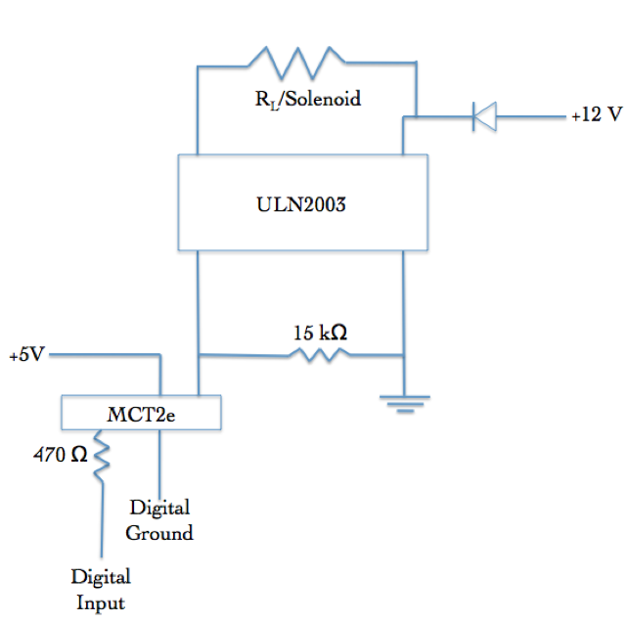

*Lick Detection circuit*

To be able to monitor the presence or absence of licks to the port, the conductive part (metal) of the lick port syringe was connected to a MOSFET such that a 5V DC voltage could be read out, whenever the animal would make contact with the port. The circuit diagram is shown below:

Parts list

1. +5V Power Supply

2. 4.7 kohm resistor

3. 22 Mohm resistor

4. IN4007 Diode

5. NPN Transistor IRF540N (MOSFET)

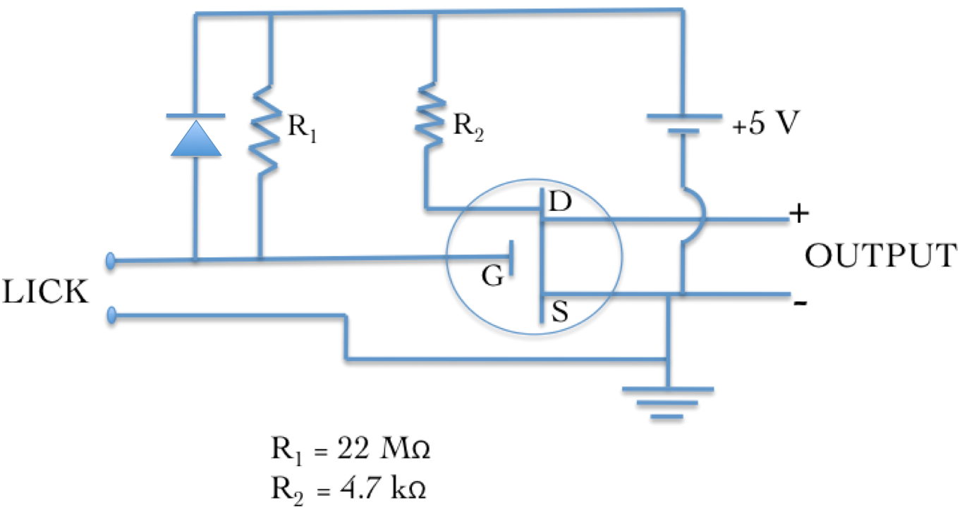

*Controlling task details and protocol information*

All protocols were controlled using custom scripts written in NI LabVIEW 8. These scripts were run on a lab desktop which interfaced with the DAQ (NI USB-6001) via USB. The DAQ,

1. Sent the 5V digital input to switch on the solenoid valve regulating water delivery
2. Received the 5V digital output of the lick detection circuit whenever a lick was produced by the animal

*Head-bar implant, Animal Handling, and Water deprivation*

All experiments were planned to be conducted on head-fixed C57Bl/6 mice, with the eventual intention to perform *in vivo* imaging on these animals. For this, we surgically implanted metal head-bars on the skull of the animals while they were maintained on 1-2% Isoflurane, above a heating pad (35℃). Surgeries would last no longer than 30 mins per animal.

After 1-7 days of recovery after surgery, we handled the animals gently for 2 days till the animals would appear comfortable with lifting and gentle collar grabbing. Next, for 3-4 days, we kept the animals head-clamped

We restricted our animals to ~1ml of water per day, keeping check that their body weight did not fall to below 80% of the weight on day 1.

*PROTOCOL 1.1: Stimulus Detection Task*

We first tried the simplest version of the lick task, wherein an auditory tone was followed by a water reward. The animal would have to withhold licking till the end of the stimulus presentation, and then perform the lick for the reward.

Total number of trials: 600/session; 1 session/day

Trial phases:

1. Stimulus-free Pre-tone (PT): 1 s
2. Tone: 5 kHz for 1 s
3. Critical Timeout (CT): 100 ms
4. Inter-trial Interval (ITI): randomized between 2 s to 5 s



Figure: Typical trial structure with the various phases. Each trial was followed by a randomized Inter-Trial Interval (ITI).

Only licks during the Critical Timeout (CT) phase immediately after the Tone phase were rewarded while licks in other phases resulted in a phase restart.

*PROTOCOL 1.2: Stimulus Detection Task with Aversive punishment*

Total number of trials: 600/session; 1 session/day

Only licks during the Critical Timeout (CT) phase immediately after the Tone phase were rewarded while licks in other phases resulted in a 100 air-puff to the body of the animal, before a phase restart. For Mouse 3 we started Protocol 1.2 from Session 3 while for Mouse 4 we started Protocol 1.2 from Session 2.

Results

The behavioural performance for each of the experiment animals was evaluated using custom analysis scripts written in MATLAB 2011. Here are the results from two mice trained based on Protocols 1.1 and 1.2.

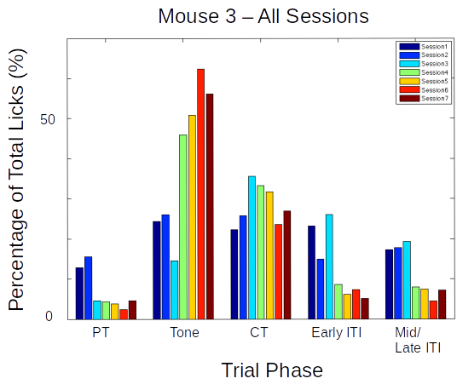

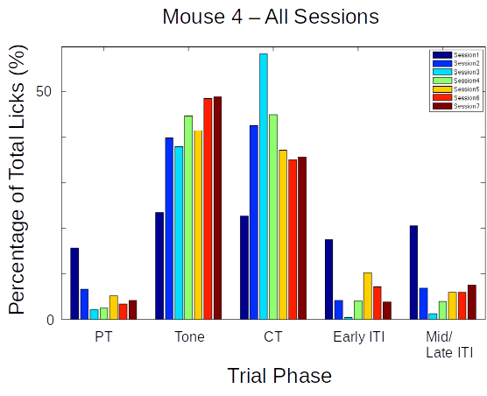

Figure: Performance evaluation for two example mice trained to Protocol 1.1. Percentage of total licks in the various trial phases (Pre-Tone, Tone, CT, and ITI), across all sessions of training (coloured bar plots)

In both the examples shown, animals would typically produce a great percentage of total licks even during the Tone period. This failure to withhold licks carried on for 7-14 sessions, and the task was ultimately unsuccessful.

Total animals trained: 2

Conclusion: Fail

*Protocol 2: Stimulus Detection task with Timeout box*

We also tried the same Stimulus Detection protocol, without an air-puff punishment, but with incorrect licks punished by a trial abort and a stimulus-free timeout phase, which the animal could escape from if it withheld licking. We decided to train the animals in blocks, each with a specific goal that the animal had to achieve.

Trial phases:

1. Stimulus-free Pre-tone (PT): 1 s
2. Tone: 5 kHz for a variable duration (based on BLOCK)
3. Critical Timeout (CT): 1000 ms
4. Inter-trial Interval (ITI): randomized between 2 s to 5 s



Figure: Typical trial structure with the various phases. Each trial was followed by a randomized Inter-Trial Interval (ITI).

Only licks during the Critical Timeout (CT) phase immediately after the Tone phase were rewarded while licks in other phases resulted in a phase restart.

BLOCK 1: Unconditional Water to get the animal to associate the tone

- ~20 trials

- 100 or 200 ms Tone duration

- Unconditional water provided at the end of the tone, irrespective of lick

BLOCK 2: Conditional Water to get the animal to learn that licking with/after tone is going to be rewarded

- 100 or 200 ms Tone duration

- 1000 ms Reward phase

- Lick during/after tone (Reward phase) = reward

- No lick = no reward

- Lick during pretone = no reward/abortion of trial

- Lick during ITI = no reward/abortion of trial

- Animals graduate to the next Block of training only after achieving at least 70-80% success rates

BLOCK 3: Training the animal to learn "when" to lick

- 1000 ms pre-tone, 100 or 200 ms Tone, 1000 ms Reward phase, 3-5 s randomized ITI

- Lick during Reward phase = reward

- Any lick during the Pretone or the tone, aborts the trial and sends the program to a Timeout phase (lasting, 2-3 s)

- The timeout phase ends only when there is a 2-3 s (specified) interval of no licking

- If the timeout phase ends, a new trial begins

- Licks during ITI are also "punished" accordingly

- Animals graduate to the next Block of training only after achieving 70-80% success rates

BLOCK 4: Same as Block 3, but with a gradually increasing tone duration in steps of 50/100 ms

- The tone duration is gradually increased, the increase being tailored to the performance of the animal

- It will be attempted to get the animals to learn to wait for upto 700-800 ms, but even upto 500 ms does not hurt the cause

- Animals graduate to the next Block of the experiment only after achieving 70-80% success rates

Results

The behavioural performance for each of the experiment animals was evaluated using custom analysis scripts written in MATLAB 2011. Here are two representative examples of mice trained based on Protocol 2 (BLOCK 3).

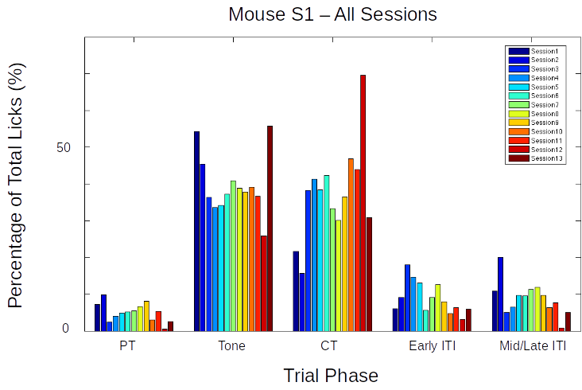

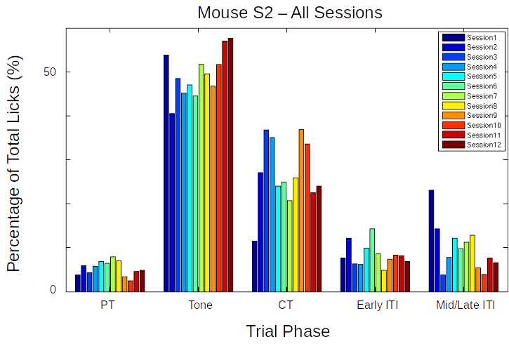

Figure: Performance evaluation for two example mice trained to Protocol 2. Percentage of total licks in the various trial phases (Pre-Tone, Tone, CT, and ITI), across all sessions of training (coloured bar plots)

Again, as is clear from the examples above, that while the mice eventually produced a decent percentage of total licks in the Critical Timeout (CT) phase to get a water reward, they did not learn to withhold licks during the Tone phase, even after >10 sessions. The task was ultimately unsuccessful.

Total animals trained: 4

Conclusion: Fail

*Protocol 3: Delayed Non-Match to Sample (DNMS)*

Delayed Non-Match to Sample (DNMS) is a task that is ideally suited to study working memory and recognition (Binder et al., 2008), but we decided to try it. This task involves trial-by-trial presentation of two stimuli separated by a stimulus-free delay interval. For any given trial, If the two pseudorandomly chosen pairs of stimuli were identical, then licks would not be rewarded. However, if the pair of stimuli were different, then licks would be rewarded with 2 µL water.

We tried to incorporate more tones, in the hope that this may improve the chances of the animals focussing on the task specifics, instead of producing licks to just any particular stimulus.

- Repertoire of Tones: 6000 Hz, 8500 Hz, 10000 Hz and 11500 Hz

Trial phases:

1. Pre-Tone duration (ms): 1000 ms
2. CS 1 duration (ms): 350 ms
3. Delay Interval duration (ms): 250 ms
4. CS 2 duration (ms): 350 ms (unless a correct lick is elicited during the presentation)
5. ITI duration (s): randomized from 1 s to 3 s

Punishment: Timeout Box (minimum of 3s of no licks to escape)

Reward: 2 µL of water

Results

>70-80% of the trials had to be aborted because the animals would not withhold licking after the 1st of the pair of tones was presented. This did not change even after 7 days (sessions) of training.

Total animals trained: 6

Conclusion: Fail

*Protocol 4: Go/No-Go Task*

In an attempt to simplify the behavioural task, we decided to reconfigure the DNMS task to a simpler Go/No-Go task. Here, we would again present the animal with two stimuli, but with the only condition being that the animal would have to lick after the second stimulus, and not before. This simplifies the behaviour to a certain extent, because the animals need only use the first stimulus as a cue for the second. Failure to perform this task could more easily then be attributed to a lack of attention in that trial. Only the data from the trials where the animal succeeds to do the task would be considered for analysis. Training related changes in actual stimulus representations would be carefully dissected out. Furthermore, such a task would control for the behavioural state of the animal and help provide important datasets.

In terms of imaging, we hoped to use the no-go stimulus to record a clean stimulus response without the possible contamination of movement (licking behaviour), and the go stimulus to verify attention.

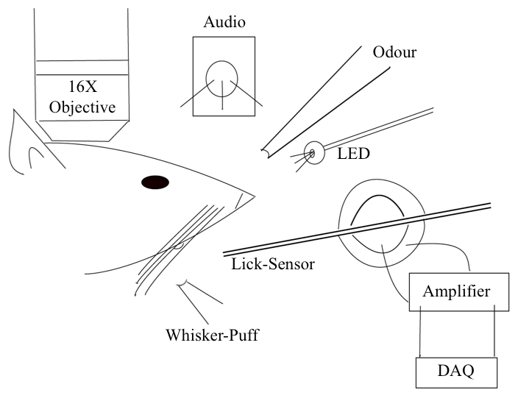

Figure: Schematic representation of the experimental setup for a simple detection task where the animal must perform a lick upon correctly detecting the presence of the conditioned stimulus (CS; from a range of modalities).

Trials were designed to go through the following phases and have the animal graduate to subsequent phases, only after correctly performing the behaviour:

1. Pre-Tone: Stimulus-free period where the animal must not perform a lick
2. No-Go Tone: a 7kHz tone period where the animal must not perform a lick
3. Go Tone: a 10kHz tone period where the animal must perform a lick

If the animal would perform an incorrect lick, the particular phase currently occurring was restarted. Only licks to the Go tone were rewarded.

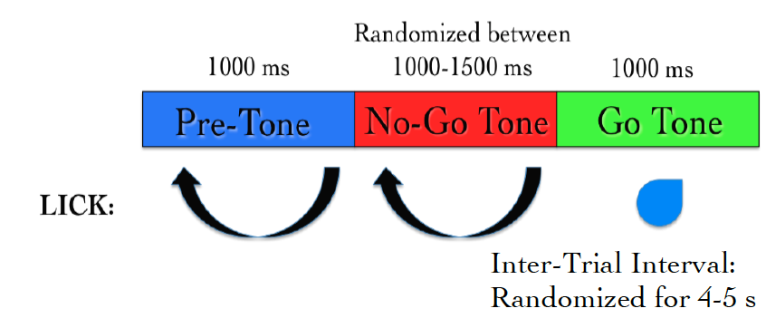

Figure: Typical trial structure with the various phases and lick dependent relationships.

Results

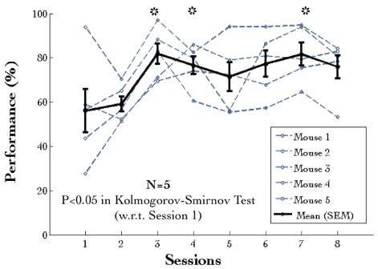

Figure: Performance traces for all the animals individually shown in dashed grey lines. Mean + SEM in black.

The behavioural performance improves only after several sessions of training (~3-4 sessions). This is primarily due to an increase in the percentage of trials with a correct Go tone lick, as shown below.

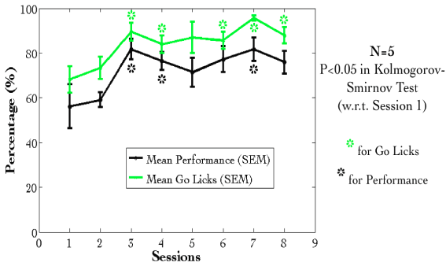

Figure: Mean Performance (%) and Mean Go Tone Lick Percentage (%) with Session for the Go/No-Go Task, plotted in black and green, respectively.

However, a plot of the lick histogram for the various trial phases revealed that despite reaching the maximum success rate, the animals continued to lick during the No-Go tone phase (incorrect lick) for a long duration of time (Figure 9). There was no difference in the amounts of time spent in the Pre-Tone or No-Go Tone phases. This suggested that the animals did not discriminate between the Go and No-Go tones. Accordingly, the current protocol was not being learnt as expected.

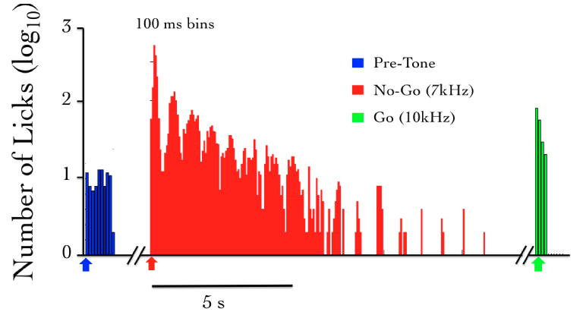

Figure: The number of licks in the pre-tone (blue), no-go tone (red), and go tone (green) phases, in a representative animal, in a session with maximum Performance (%).

We were not able to get discriminatory detection. Animals would resort to performing licks continuously and agnostically to the go and no-go stimulus. In a study published many years later, it was determined that any discriminatory task such as the one described above, would require even up to 4 weeks of training, since the animal was not punished with anything more than a delay or phase restart.

Total animals trained: 5

Conclusion: Fail

We later had to abandon these experiments, to switch to an aversive conditioning task, viz., Trace Eye-Blink Conditioning (TEC). With the change in the main behavioural task we also changed the project goals. The TEC task was standardized with the intention to work on Project II which is to study how animals make complex associations between different types of stimuli and how they adapt to changes to the Interstimulus Interval (ISI).

TRACE EYE-BLINK CONDITIONING (AVERSIVE CONDITIONING)

Eye-blink Conditioning is a class of Classical Conditioning and requires the presentation of a neutral stimulus (Conditioned Stimulus, CS) along with an eye-blink eliciting, mildly aversive stimulus (Unconditioned Stimulus, US). Depending on whether the CS presentation overlaps with the US presentation or if the two stimuli are separated by a stimulus free interval in between (Trace Interval), the concomitant procedure is called Delay Conditioning or Trace Conditioning, respectively. In either case, precise timing of the CS and US is mandated.

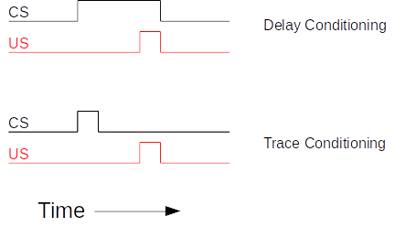

Figure: Schematic representation to showcase the two main subtypes of Classical Conditioning (Eye-Blink Conditioning, for our experiments) based on the relative timing and presentation of the CS and US.

The CS is usually an auditory tone or a visual stimulus (e.g.- LED Flash), while the US is typically a mild air-puff to the cornea, or a gentle electric shock to the eye-lid. Naive animals (rabbits, rodents, monkeys, etc.) produce a robust, reflexive eye-blink to the US (Unconditioned Response, UR) and ignore the CS, in early trials. However, with repeated pairing of CS and US, the animals are able to associate the two, and use the CS as a cue to predict the US, producing a partial, preemptive eye-blink just before the expected time of the US (Conditioned Response, CR). The CR develops in amplitude over multiple pairings or training sessions. In well trained animals, the CR begins at a time point closer and closer to the CS onset, and usually merges with the UR. The animals produce this CR in an attempt to avoid the US.

Traditionally, Trace Eye-Blink Conditioning has been an important hippocampus-dependent behavioural task, and has been adapted to a variety of different species, spanning rabbits, rats, and mice.

Damage or inhibition of the hippocampus has been shown to limit task acquisition without affecting other non-hippocampus dependent tasks such as Delay Conditioning. In the experiment shown below (Tseng et al., 2004), Ibotenic Acid was used in a session dependent fashion, to observe both limitations in first acquiring the Trace Conditioning task, as well as detriments to behavioural recall, even after animals learn the task to a high degree of proficiency, suggesting the pivotal role that the hippocampus plays in temporal tasks of this nature.

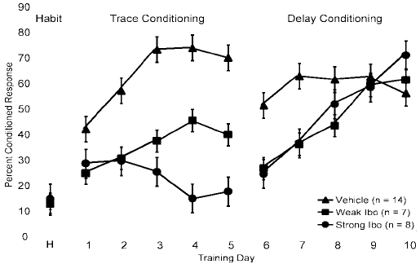

A single session of Trace Eye-Blink Conditioning, with strong stimuli (CS and US), has been previously employed (Modi et al., 2014), but with only upto 50% of the animals learning the task. Typically animals require around 3-7 sessions (~200-600 trials) to robustly learn the task. Accordingly, we designed and standardized a multi-session version of TEC, to allow more animals to learn and acquire the task.

*Tracking Eye-Blink Responses*

The most foolproof way to track eye-blink responses (especially with head-fixed animals) chronically (for multiple sessions across days), is to use a video camera. We used a Point Grey Chameleon3 1.3 MP Monochrome USB3.0 camera) for this purpose. It is cost effective and with proper scaling of the resolution and field of view, can achieve recording rates of >200 frames per second. An important criteria for getting faster frame rates is to have better illumination, so that the camera may be set to lower exposure settings. We used a set of 5-10 Red colour LEDs as the light source, and these are run using a 12V DC line, with current limited resistors in series. Additionally, we used an IR-blocking filter to avoid capturing the two-photon excitation light (910-920 nm) when conduction behaviour and imaging experiments simultaneously. Finally, to focus the light from the eye of the animal onto the camera sensor, we used a Tamron M118FM16 lens (1/1.8, 16mm F/1.4).

*Treadmill and tracking running speed*

Allowing the head-fixed animals to run on a treadmill was an important behaviour rig consideration, as this allows the animals to be more comfortable and less stressed. We used a 6 inch cylindrical massage roller with a stainless steel axle running along the length. This axle had ball bearings on the two ends, to allow for free rotation against clamps. Additionally, we used linear actuators to be able to adjust the height of the treadmill relative to the head-fixing clamps.

On one side of the treadmill, we used a printed pattern of black squares (side length: 1cm) along the circumference. This allowed an IR LED - Photodetector pair to catch the edges of the black printed squares. The number of edges detected per unit time, then gave us the run speed of the animals being trained. We followed Siegel et al., 2015 for setting up the treadmill and run speed tracking.

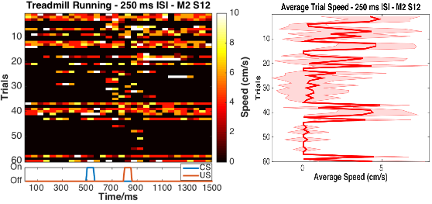

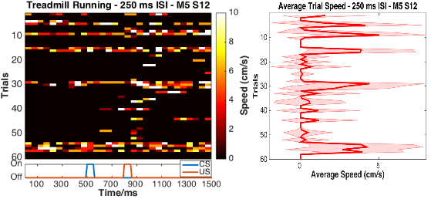

Figure: Trial by trial (left), and trial-averaged running speed (right) for two example animals (top and bottom).

*Behaviour rig and protocol control - Software*

For our initial experiments we used the open-source behaviour controlling software suite Bonsai (Windows version). Later on, we were able to implement our own custom codes that allowed integration of the video camera, Arduino for stimulus delivery and treadmill tracking, and the software side of the protocols. Dilawar S. Rajput was instrumental in setting up the camera pipeline and integrating it into the Arduino code. The Camera server was implemented in C++ with Spinnaker API (Point Grey) and this fetched frames from the camera. The camera client was written in python, and this read the frames to produce a copy to monitor the video feed live, as well as write the video frames to disk as .tiff files.

With this setup, the maximum memory usage was ~1.3 GB RAM, and the code (available at <https://github.com/BhallaLab/PointGreyCamera>) had the following dependencies:

* libopencv-dev, python-opencv
* cmake, g++, gnu-make
* libtiff-dev, python-tifffile, python-numpy
* python-gnuplotli, gnuplot-x11

[Lead in listing the kinds of variations you developed on the TEC task]

We used a blue LED as the Conditioned Stimulus (CS, 50 ms flash) with an air-puff to the eye serving as the Unconditioned Stimulus (US, 50 ms pulse). We used an Arduino to orchestrate stimulus delivery and protocol design.

All experiments were performed on head-fixed C57Bl6 mice, since we planned to use a stationary, custom-built two-microscope to image Hippocampal CA1 activity during task acquisition and recall.

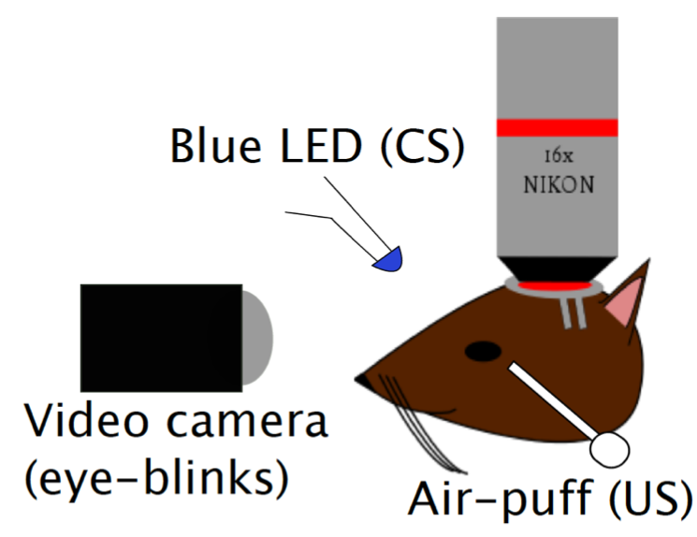



Figure: Schematic representation of the behaviour rig with two-photon imaging, to train head-fixed mice on a Trace Eye-Blink Conditioning (TEC) task.

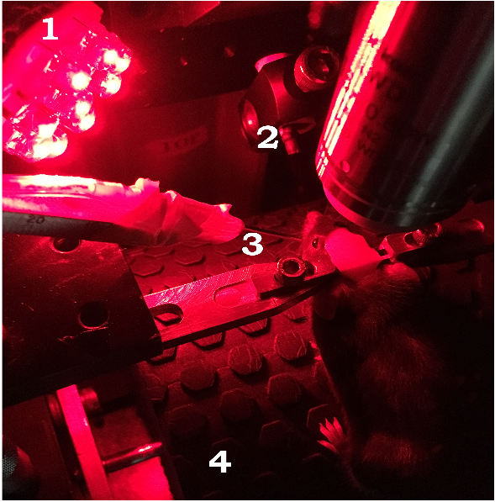

Figure: A picture of a head-fixed mouse clamped on the behaviour rig, with key components: 1) Red LED Illumination, 2) Blue LED CS, 3) Air-puff port directed to the left eye, and 4) Height-adjustable Treadmill

Analysis

Once the .tiff movies of the eye of the animal being trained were saved, they were analyzed by a custom script written in MATLAB 2011, wherein for every frame we

1. Adjust contrast (optional)
2. Apply a median filter (optional)
3. Crop out the pixels defining the eye and surrounding (identical number of pixels for all trials and animals)
4. Binarize the image of the eye to get black pixels defining the visible (opened) portion of the eye
5. Count the relative proportion of open vs closed eye pixels in the cropped image, and
6. Assign each frame with a Fraction of Eye Closure (FEC) score

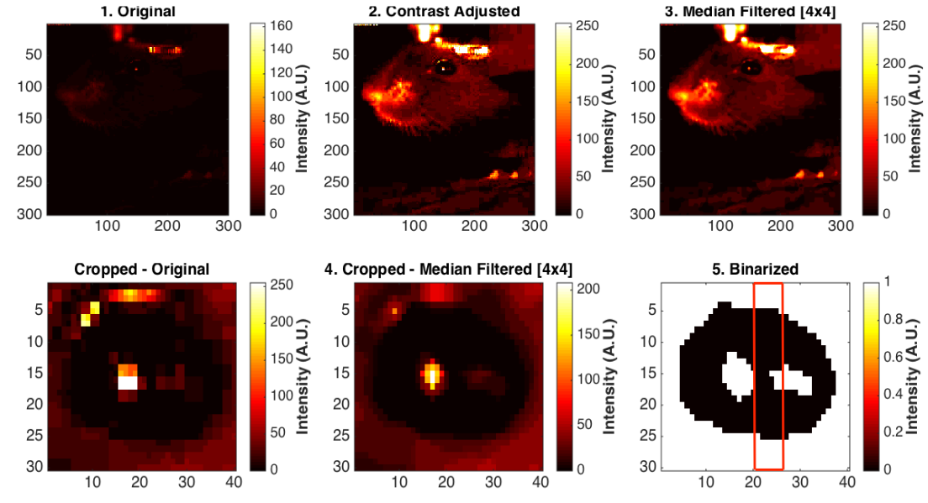

The FEC score then allowed us to analyse each trial’s worth of frames for eye-blinks.

There are many features of the eye-blink that could be used to gauge the overall performance of the animal in terms of both the Conditioned Response (CR) as well as the Unconditioned Response (UR), but for my experiments, I chose to use Eye-Blink Amplitude (Siegel et al., 2015).

Additionally, we studied whether the animals could produce CRs in the absence of the US, by pseudorandomly selecting upto 10% trials to skip the US (Probe Trials).

Results

1. Animals showcase task acquisition by performing Conditioned Responses (CRs), observed as pre-emptive blinks timed to avoid the aversive US. The kinetics of the CR (timing, amplitude, etc.) are dependent on the amount of training, but are identical across paired and probe trials.

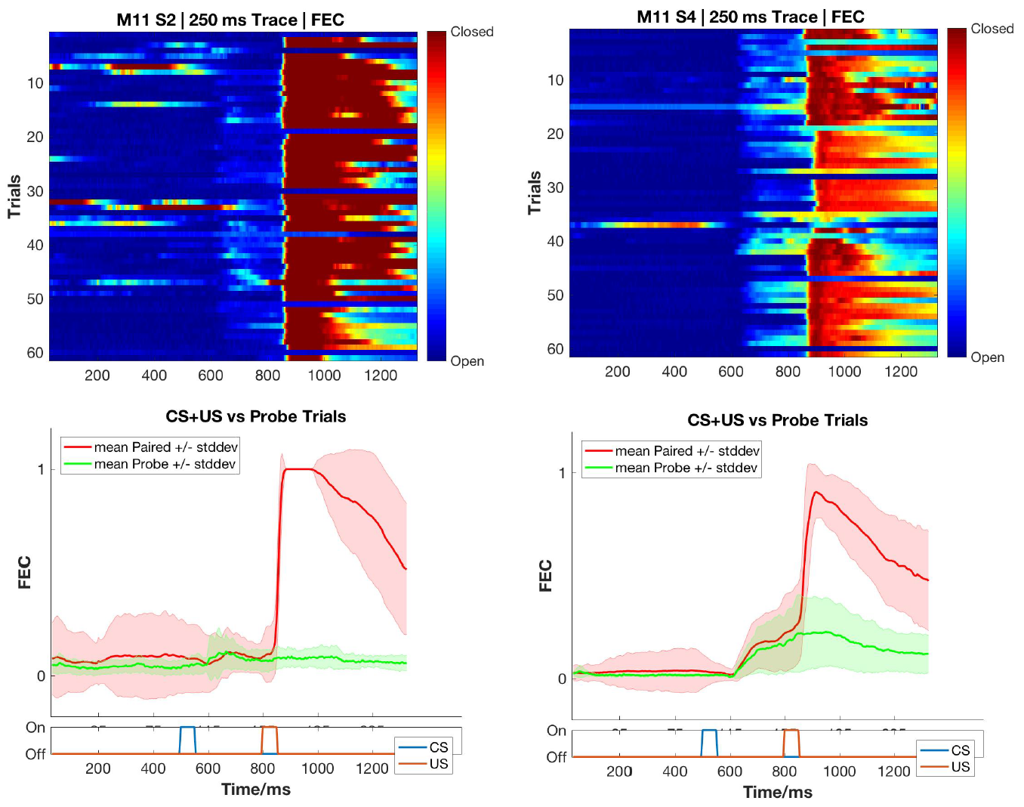

Figure: Conditioned Responses (CRs) are small amplitude eye-blinks triggered by the CS, and develop with multiple training sessions. *Top*, Trial-by-trial FEC scores for Session 2 (*left*) and Session 4 (*right*). Unconditioned Responses are large eye-blinks to the US. *Bottom*, Trial-averaged FEC traces for Session 2 (*left*) and Session 4 (*right*) for paired (red) and probe trials (green).

1. Most animals can pick up the task within 4-7 sessions (1 session/day, 60 trials/session), even if on water deprivation. Animals can also be subsequently trained to different Interstimulus intervals. Using the Conditioned Response (CR) amplitude, each trial can be binarized to whether a CR was elicited (Hit Trial) or not (Miss Trial), by thresholding at mean trial FEC + 2*Std. Dev.. Performance for the session is then estimated as the ratio of Hit Trials to Total Trials.

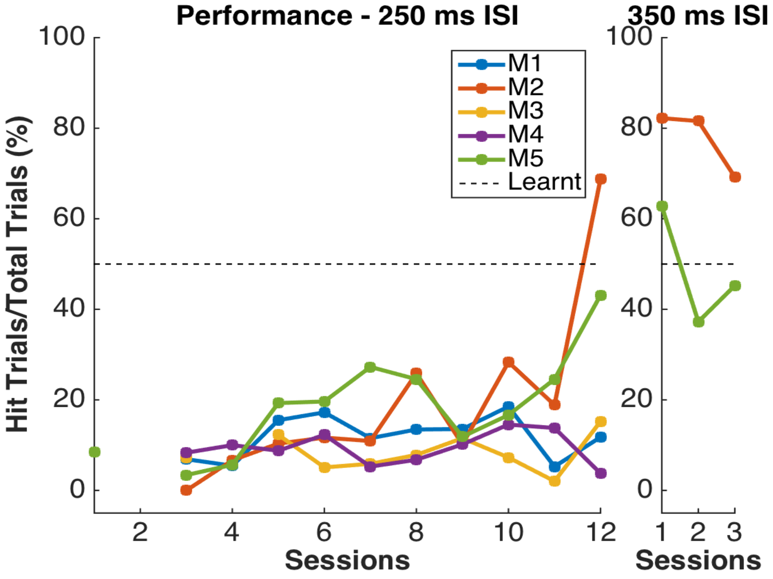

Figure: Performance in terms of the percentage of Hit Trials to total trials across sessions, including an ISI switch from 250 ms to 350 ms.

1. Animals that learn multiple ISIs, especially when the second ISI is >=2x the first ISI, showcase complex eye-blinks without extinction of the previously learnt CRs. Once an animal showcases the ability to produce Conditioned Responses (CRs) to one inter-stimulus interval (ISI), this interval can be elongated. In the example shown below we first trained the animal to a 250 ms ISI, and then switched to a 500 ms ISI.

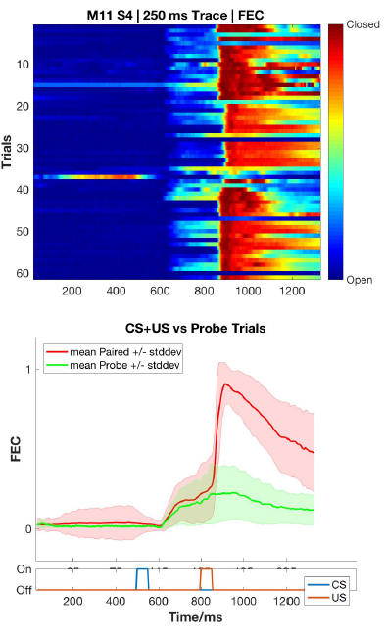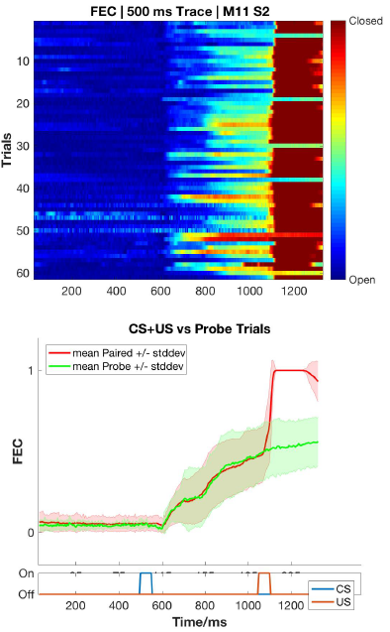

Figure: Conditioned Responses (CRs) are preserved for previously learnt ISIs, and switching the ISI to longer intervals results in Complex (multi-CR) eye-blink responses. *Top*, Trial-by-trial FEC scores for 250 ms ISI (*left*) and 500 ms ISI (*right*). Unconditioned Responses are large eye-blinks to the US. *Bottom*, Trial-averaged FEC traces for 250 ms ISI (*left*) and 500 ms ISI (*right*) for paired (red) and probe trials (green).

1. The onset of the Conditioned Response (CR) is not affected by the ISI switch, irrespective of how strongly the animals learn the task. CRs during paired and probe trials were near identical, showcasing that the animal

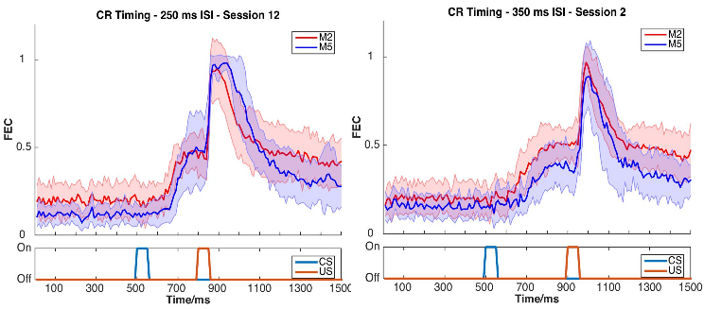

Figure: Conditioned Response (CR) onset timing is maintained across ISI switches. Representative examples from a short ISI switch from 250 ms (*left*) to 350 ms (*right*).

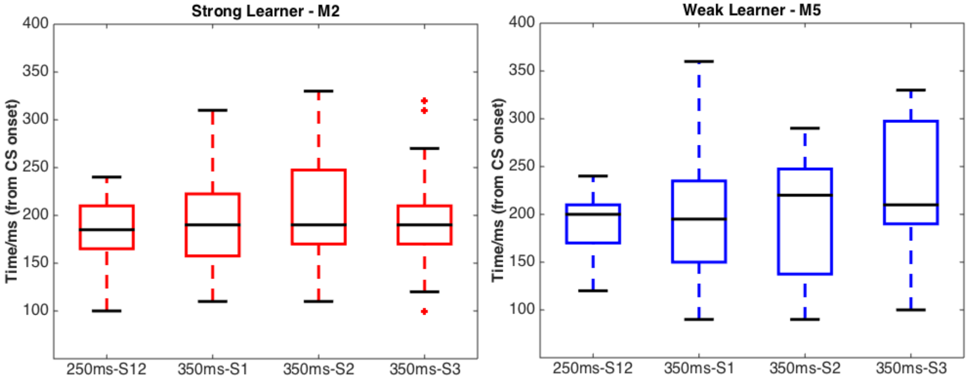

Figure: Bar plots for Conditioned Response (CR) onset across multiple sessions of training after ISI switch from 250 ms to 350 ms, irrespective of how strongly the animals learnt the task. *Left; red*, strong learner, and Right; blue, weak learner.

1. Animals can also be trained to very long ISIs from Session 1, with acquisition taking <10-14 days. Here we tried to train animals to either a 550 ms ISI or a 750 ms ISI. Note, however, that unless multiple ISIs are taught to the same animal, the CR eye-blink is singular.

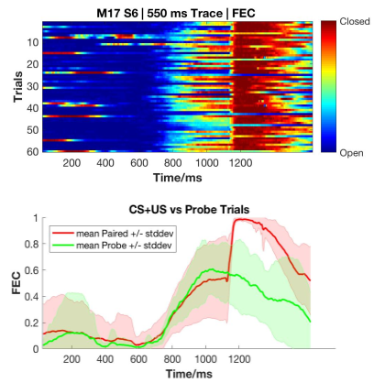

Figure: Representative example of a mouse trained to 550 ms ISI (Session 6). *Top,* Trial-by-trial FEC responses, and *Bottom,* Trial-averaged FEC responses for paired (red) and probe trials (green).

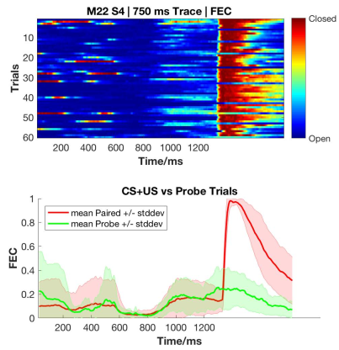

Figure: Representative example of a mouse trained to 750 ms ISI (Session 4). *Top*, Trial-by-trial FEC responses, and *Bottom,* Trial-averaged FEC responses for paired (red) and probe trials (green). Here the CR is weaker, but clear from the FEC heatmap.

Total animals trained: <check lab notes>

Conclusion: Success